Goal 1:  Parts of a wave  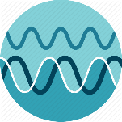 | Rally Read “Waves Types” CK12 Flexbook and “Parts of a Wave” CK12 Flexbook. Update your note guide by answering the learning targets.
 | Choice A – Quizlet Flashcards |  | Choice B – Interactive Labeling Activity
 | Choice A – Find a shoulder partner and sketch/label a transverse wave and a longitudinal wave. Compare and contrast your drawings and their labels to clarify any misconceptions. |  | Choice B – Use Rally Coach as you and a partner have a Science Talk on the parts of transverse and compressional/longitudinal waves. Be sure to clean up any misconceptions before switching roles. Click here for access to the activity.
Goal 2: Behaviors of a wave  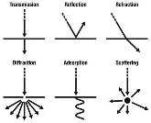 | Watch the two videos from the learning module to see how waves behave. Take a one-minute timed pair share each, to debrief on what you learned after each video  Video #1 and Video #2
 | Choice A – Quizlet Flashcards |  | Choice B – PhET Waves Simulation and PBS Learning Activity
 | Science Talks – Find a shoulder partner and discus waves behaviors. Be sure to include reflection, refraction, absorption and diffraction. Update your note guide.
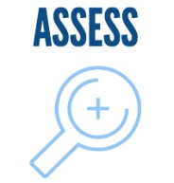 | Check Up – Your goal for content mastery is 80% or better on the assessment | Choice A – Move to Goal #3 if you showed content mastery | Choice B – Use the Waves PowerPoint to remediate and build fluency | Choice C – Find a peer or your teacher for small group remediation and review in preparation for credit recovery
Goal 3:  Earthquakes: S-waves & P-waves | Rally Read about P-waves and S-waves here and update your note guide.
 | PICK TWO
 | Choice A – Video #1 and Video #2 | Choice B – Interactive #1 and Interactive #2 | Choice C – Additional Reading with interactive questions | Choice D – Quizlet Flashcards
 | Check Up – Your goal for content mastery is 80% or better on the assessment | Choice A – Move to Goal #4 if you showed content mastery | Choice B – Use the SlideShare presentation to remediate and build fluency | Choice C – Find a peer or your teacher for small group remediation and review in preparation for credit recovery
Goal 4: Light waves travel as transverse waves | Read “The Electromagnetic Spectrum” CK12 Flexbook to see how light waves travel as transverse waves using the electromagnetic spectrum. Update your note guide by answering the learning targets.
 | Step 1 – Take 2-3 minutes for a Science talk and share what you wrote on your note guide | Step 2 – Make any changes or additions after both people have taken a turn | Step 3 – Create an acronym saying to help you remember the order for the waves on the EMS and share with at least 3 people | Step 4 – Select the acronym that is the catchiest and write your saying 10 times each to help you better recall the order
 | Check Up – Your goal for content mastery is 80% or better on the assessment | Choice A – Move to Goal #5 if you showed content mastery | Choice B –Labeling Game #1 and Interactive | Choice C – Find a peer or your teacher for small group remediation and review in preparation for credit recovery
Goal 5:  Sound:  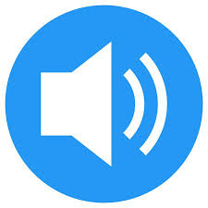 | Read “The Characteristics of Sound” CK12 Flexbook to see how sound travels through different mediums and how sound is measured. Update your note guide by answering the learning targets.
 | Step 1 – Watch the video to see how sound travels through matter | Step 2 – Explore the Interactive on how travels through different types of matter | Step 3 – Watch the video to see how sound is measured using the terms frequency, pitch, amplitude and loudness (F-P-A-L) | Step 4 – Discuss Goal 5 material with your shoulder partner and update your note guide
 | Check Up – Your goal for content mastery is 80% or better on the assessment | Choice A – Move to the study guide if you showed content mastery | Choice B – Revisit previous steps or research information on your own | Choice C – Find a peer or your teacher for small group remediation and review in preparation for credit recovery

Quiz Preparations

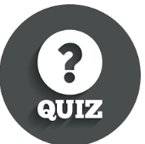 | Step 1 - Spend 15 minutes working on filling in the appropriate answers to the study guide. DO NOT use your note guide or any other resource! | Step 2 – Spend another 10 minutes in Science Talks with your peers and note guide. Use the answer key to check your answers and fill in missing responses or make necessary changes. | Step 3 – Play Quizizz in class and try to score 80% or better. Your teacher will provide you with the class code. | Step 4 - Take your quiz and post your answers to Edmodo. Your teacher will provide you with directions for credit recovery if you score below an 80%.

