Name___________________________________
6.P.1.1 – Waves Study Guide
Transverse Wave (Light):  Draw and label the parts of a transverse wave.  A wave type that has movement __________ to the direction of the wave? | Longitudinal Wave (Sound):  Draw and label the parts of a longitudinal (compressional) wave.  A wave type that has movement __________ to the direction of the wave?
Surface Wave:  What is a surface wave? | Seismic Waves:  What is a seismic wave?  P-waves?  S-Waves?
Wave Behaviors - Reflection/Refraction/Diffraction:  What is reflection?  What is refraction and why does it occur?  What is diffraction?  What is absorption? | Properties of Waves (3):  Amplitude -  Frequency -  Wavelength -  *As wavelengths increase, frequency __________.  *As wavelengths decrease, frequency __________.  *Frequency is measured in __________ (Hz).
How Does Light Travel as Transverse Waves:  Light waves _____ travel across a vacuum. They _____ need particles to travel. This is why light can travel across space. They form part of the electromagnetic spectrum and travel very fast. About 300,000,000 m/s.  Light Waves = ________________ waves | What do you see???  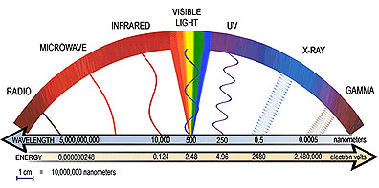
How Do Sound Waves Travel Through Matter:  All sound waves require a medium (plural, media). Most of the sounds that you hear travel through air at least part of the time. But sound waves can also travel through other materials, such as water, glass, and metal. No sound in space!  How low or high a sound seems to be is the pitch of that sound.  - High volume = __________ pitch  - Low volume = __________ pitch | Why does an object appear black, white, or red?  - Black: All colors from light are _________ and no light is reflected.  - White: All colors from light are reflected.  - Red: All colors of light are absorbed but only _____ is reflected back to your eyes.

