Goal 1:  Structure of the eye, the function of each and conditions that affect sight  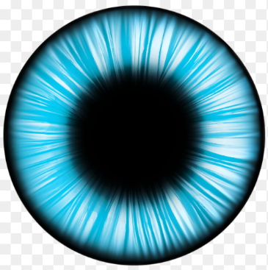 | Read the CK12 Flexbook on “Vision” and the link on “How the Eyes Work”. Read about the cones and rods within the eye. Update your note guide by answering the learning targets.
 | Watch Video #1 and Video #2 to learn more about the structure of the eye and the job of each.
 | Choice A – Quizlet Flashcards |  | Choice B – Anatomy of the Eye Interactive Labeling Activity
 | Choice A – On your Smartphone, download Eye Decide by Orca Health. Explore the app and all that it offers. |  | Choice B – Parts of the Eye PowerPoint
 | Modeling the Eye Challenge – Find a partner from another area of the room and challenge them to a timed competition. Draw the eye and label each part, 5 times. See who completes the challenge first.
 | Science Talks – The loser of the Model the Eye Challenge will begin by selecting a part of the eye and explaining to his/her partner the function. The winner will make give feedback about accuracy. Switch roles when done.
 | Learn about sight loss by selecting from the 2 choice to the right | Choice A – Watch Video #1 | Choice B - See what TeensHealth has to say on their website about vision impairment | Choice C – Go to the Prevent Blindness website. Select 2-3 eye problems and discover the cause/effect for each.
 | Enrichment Opportunity: EMS/Light/Sight  → | Watch Video #1 and Video #2 about the behaviors of waves | Refer back to your Waves note guide for a refresher on the behavior of waves | Think critically about why a green plant is green.
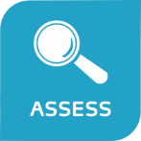 | Check Up – Your goal for content mastery is 80% or better on the assessment | Choice A – Move to Goal #2 if you showed content mastery | Choice B – Practice labeling the parts of the eye with the Interactive Quiz | Choice C – Find a peer or your teacher for small group remediation and review in preparation for credit recovery
Goal 2:  Compare and contrast types of waves  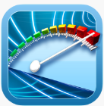 | Refresh your memory on the “Electromagnetic Spectrum” CK12 Flexbook and then visit the NASA website. Look over the CK12 Flexbook on “Light” when you are done. Update your note guide.
 | Step 1 – Go to the Electromagnetic Spectrum website and explore each page as you look for two examples of each wave type. | Step 2 – Create your own funny saying which orders the types of waves found on the EMS, based on the wave frequency. Record the saying for visible light also. | Step 3 – Share your funny sayings with your neighbors and vote on the most original which will also be the easiest to memorize. Be ready to share your selection with the class. | Step 4 – On your note guide, select the funny saying that works best for you. Record it onto your note guide and add examples of each wave type as well.
 | Compare and Contrast Activity – Ask your teacher for one sheet of construction paper and a set of markers. With your partner, create 4 separate Venn diagrams where two waves from the EMS are analyzed. Be ready to select one Venn Diagram to share with the class.
 | Check Up – Your goal for content mastery is 80% or better on the assessment | Choice A – Move to “Quiz Preparations” if you showed content mastery | Choice B – Quizlet digital flashcards  - EMS set  - Visible light spectrum set | Choice C – Find a peer or your teacher for small group remediation and review in preparation for credit recovery

Quiz Preparations

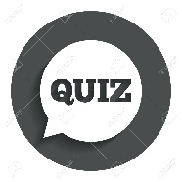 | Step 1 - Spend 15 minutes working on filling in the appropriate answers to the study guide. DO NOT use your note guide or any other resource! | Step 2 – Spend another 10 minutes in Science Talks with your peers and note guide. Use the answer key to check your answers and fill in missing responses or make necessary changes. It can be found at the bottom of the page | Step 3 – Play Quizizz in class and try to score 80% or better. Your teacher will provide you with the class code. | Step 4 - Take your quiz and post your answers to Edmodo. Your teacher will provide you with directions for credit recovery if you score below an 80%.

