Name___________________________________
EMS/ Light – Study Guide
Directions: Use multiple resources (flexbooks, learning module, science website, etc.) to complete the graphic organizer on light and the electromagnetic spectrum.
Electromagnetic Spectrum:  Draw and label the electromagnetic spectrum.  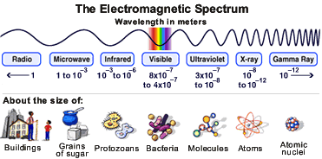  *Sometimes images of the EMS will be in the reverse order | Visible Light:  What colors are included in visible light (use acronym to help)?  R-O-Y-G-B-I-V  Draw a diagram to show what colors have the largest and smallest wavelength?  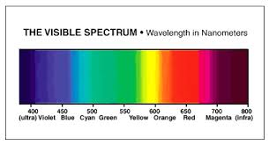
Absorption:  What is absorption?  Matter can capture electromagnetic radiation and convert the energy of a photon to internal energy | Scattering:  What is scattering?  When a beam of light is redirected in many different directions when it interacts with a particle of matter.
What medium does light travel through fastest?  Light travels the fastest in a vacuum  Light travels slower in solids, liquids, and gas.  Light travels faster than sound. | Refraction:  What is light refraction?  When light moves from one substance to another it changes speed and direction  What happens when white light is refracted?  You can see the light spectrum (rainbow) because each color travels at a different speed.
Transparent, Translucent and Opaque:  What is transparent? Allow light to pass through easily  What is translucent? Allows light to pass through, but you can’t see the objects behind it clearly.  What is opaque? Allows no light to pass through it. | Why does an object appear black, white, or green?  - Black: All colors from light are absorbed and no light is reflected.  - White: All colors from light are reflected  - Green: All colors from light are absorbed but only green is reflected back to your eyes.

