- I will identify the structures within the ear.

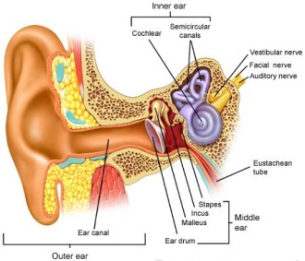

- I will explain the functions of the ear structures.
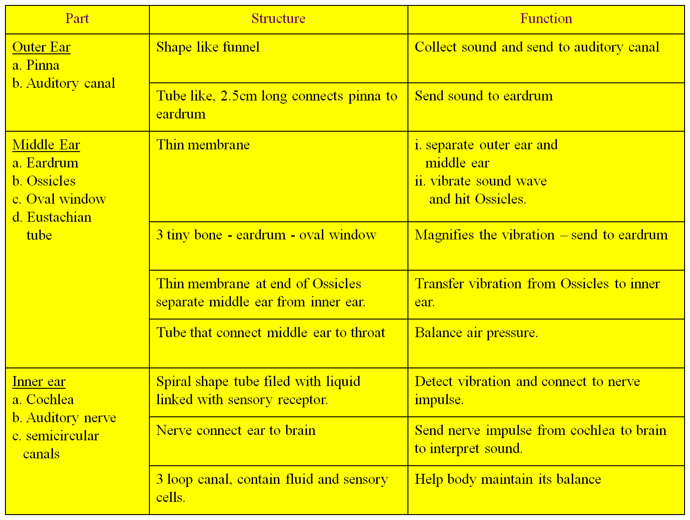

Student Notes:

- I will explain conditions that affect hearing.
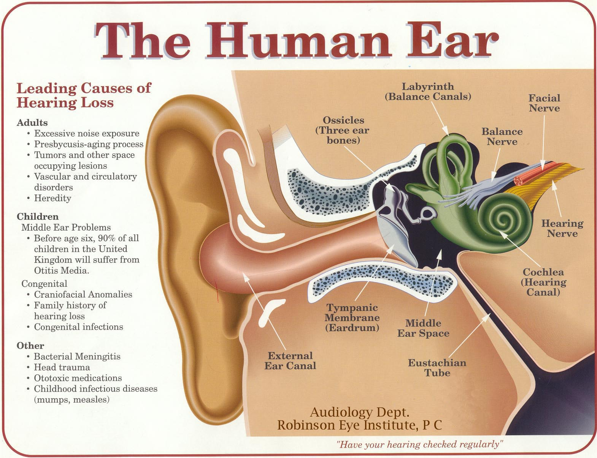
- I will identify the structures of the vocal cords.
- I will explain the function of the vocal cords

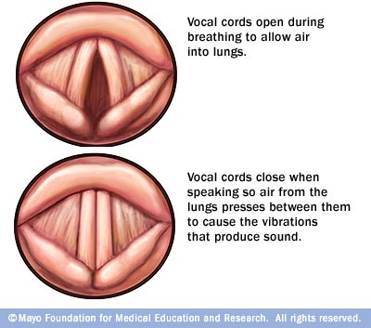

Student Notes:

f) I will explain conditions that affect the sound vocal cords make.
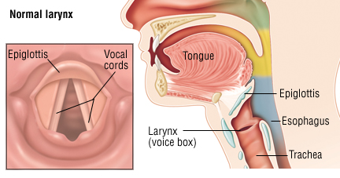

g) I will interpret how different mediums affect the speed of sound.
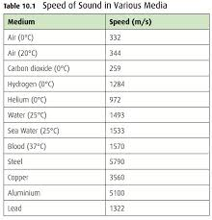
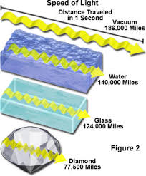
Student Notes:

h) I will explain how sound moves from one place to another.
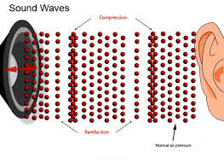

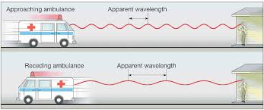

6.P.1.3 Summary - Something can be "heard" when sound waves from it enter the ear. Sound is a form of energy that is caused when vibrating materials produce waves that move through matter. These waves have different characteristics such as frequency and amplitude, which will determine the properties of sound such as pitch and loudness.

The form of the human ear can receive sound waves as vibrations and convert them to signals that are processed by the brain. Investigate how sound travels through different solid materials. Compare how sound travels through different states of matter. Investigate how the vocal cords work to produce sound: structure of vocal cords, function of vocal cords and conditions that affect the sound vocal cords make. Investigate how the ear works: structures within the ear, functions of those structures, conditions that affect hearing.
Student Notes:

