I. I can explain wave properties and behaviors.
a. I will name 3 types of waves and identify the parts of a wave.
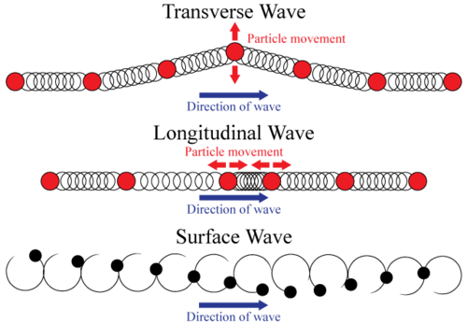

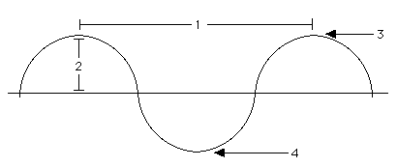

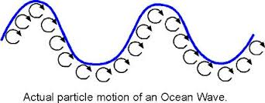

b. I will demonstrate behaviors of waves

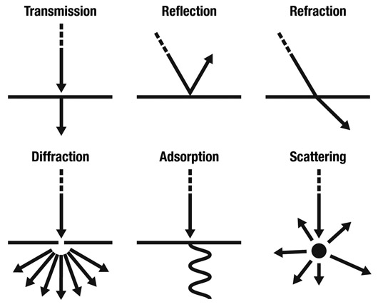

II. I can compare the properties of waves to the wavelike property of energy in earthquakes
a. I will explain the behavior of “s” waves and “p” waves in earthquakes.

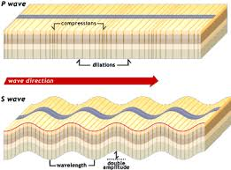

III. I can compare the properties of waves to the wavelike property of energy in light.

a. I will explain how light waves travel as transverse waves.

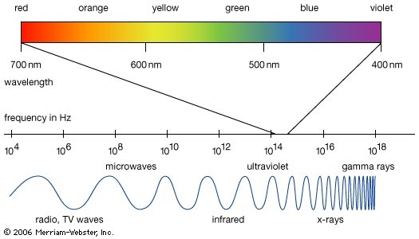

IV. I can compare the properties of waves to the wavelike property of energy in sound.
a. I will describe how sound waves travel through matter.

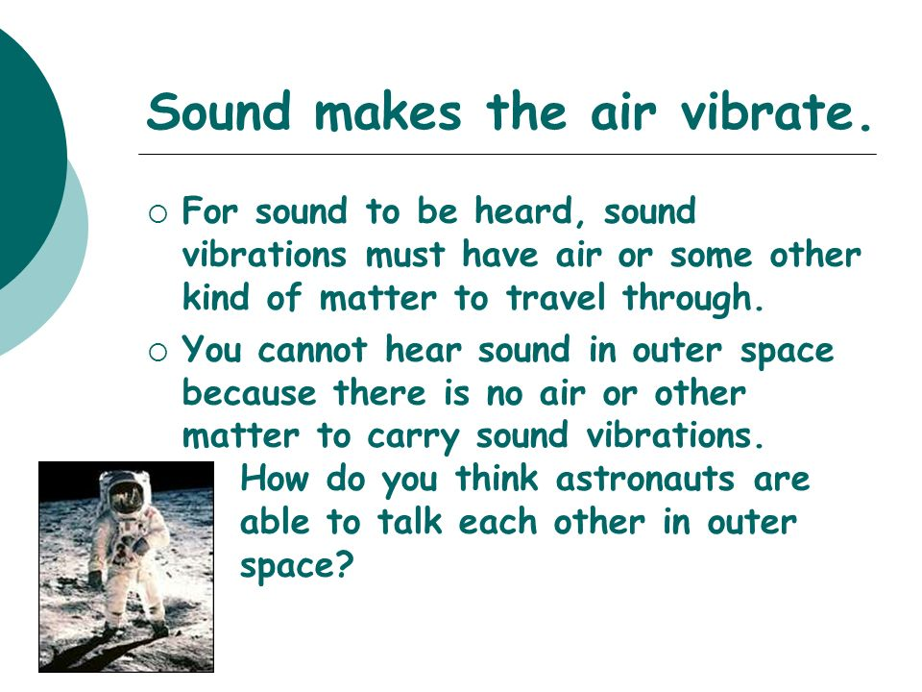

b. I will describe how sound can be measured as pitch, loudness (volume), frequency, and amplitude.
